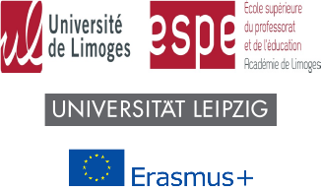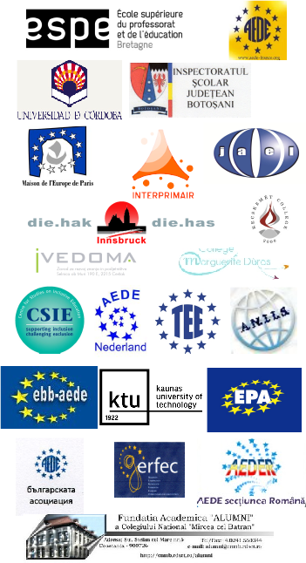

This project has been funded with support from the

European Commission.

This publication reflects the views only of the author, and the Commission cannot be held responsible

for any use which may be made of the information contained therein

Illustrations

1/ ELICIT-Plus logo designed by Paul Geurts,

2/ Original drawing by Jeanne Vitel, www.lespeinturesdejeanne.com

3/ *The abduction of Europe*, Greek vase painting, 490 B.C.

Museo Nazionale, Tarquinia, Italia

**IMPROVING EDUCATION IN EUROPE**

**http://www.elicitplus.eu**

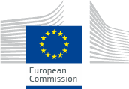

2014-1-FR01-KA200-002362

http://www.elicitplus.eu

ELICIT-PLUS

European Literacy and Citizenship Education

ELICIT-PLUS

is a project for

School Leaders, Teachers, Parents and other Educational Partners

It aims at promoting innovative educational practices to develop active European citizenship in several areas, such as:

intercultural, professional, social, economic, civic.

That is why ELICIT-PLUS is offering several study programmes and pedagogical tools.

ELICIT-PLUS

offers

Intensive Study Programmes for teachers, trainers, educational staff, parents and learners - eligible to European Mobility Grants within Erasmus+

•

a Portfolio of the European Citizen

•

a European Label

•

Pedagogical resources

•

a Common European Mention for Teacher Qualification

Find out more on

http://www.elicitplus.eu

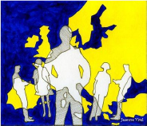

European literacy is the sum total of active knowledge about Europe, past and present. It is a complex fabric of interwoven philosophies, histories, cultures, myths and legends, religions, languages, geography, economy, geopolitics.

It is the kaleidoscope of multiple perspectives on our shared history.

It is our common past and the future that we must build together.

